# Technical Documentation

This document describes how to configure the entire Datawarehouse on a local machine.

Required Software

The following list of software need to be installed before proceeding with the installation of the solution:

1. Git v. 2.44.0
2. SQL Server (install and configure a local instance) v. 2022 (16.0.1000.6). ⚠️Important: choose SQL Server Developer version and install *Integration Services*
3. SQL Server Management Studio (SSMS) v. 2024 (20.0).
4. Visual Studio v. 16.11.34
5. Data Tools Integration Services for Visual Studio 2019
6. Draw IO v24.1.0

To install SSIS, we can do it via executables or if it doesn’t work, directly on Visual Studio by using extensions. It depends on the Visual Studio version.

1. Power BI Desktop

Installation procedure

* Clone the public repository with the following instruction:

*git clone* [*https://github.com/myDelevop/ForeignExchangeRateDWH.git*](https://github.com/myDelevop/ForeignExchangeRateDWH.git)

* *Open SSMS and Connect to the local installed instance of DB. Then, right click on DB name, go to Properties, go to Security tab and choose* “*SQL Server and Windows authentication mode*”  
  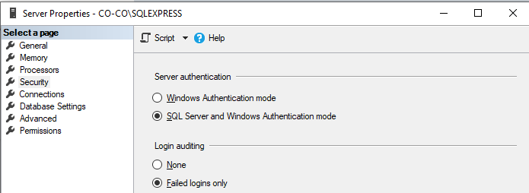
* Then, open SQL Server Configuration Manager, open protocols and go to properties on TCP/IP protocol. Set Enabled Yes and TCP port equals to the default SQL Server Port: 1433  
  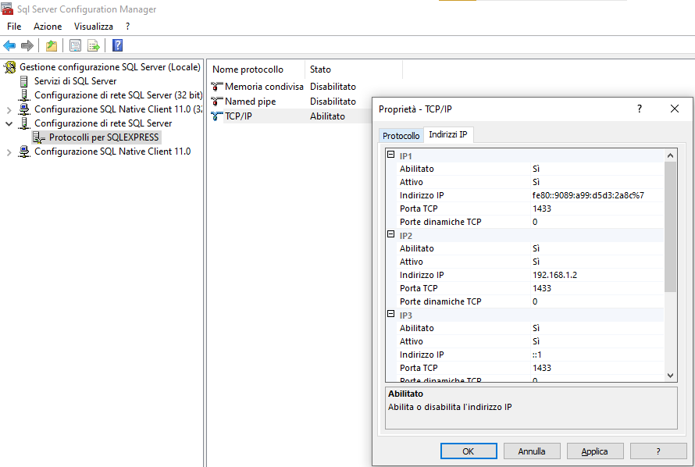
* Restart the database service this will allow us to connect by using 127.0.0.1 (localhost)
* Run the script in *README.md* on the localhost (or servername) instance in the SQL Server DB. This allows us to create the databases in SQL Server that will contain our Datawarehouse  
    
  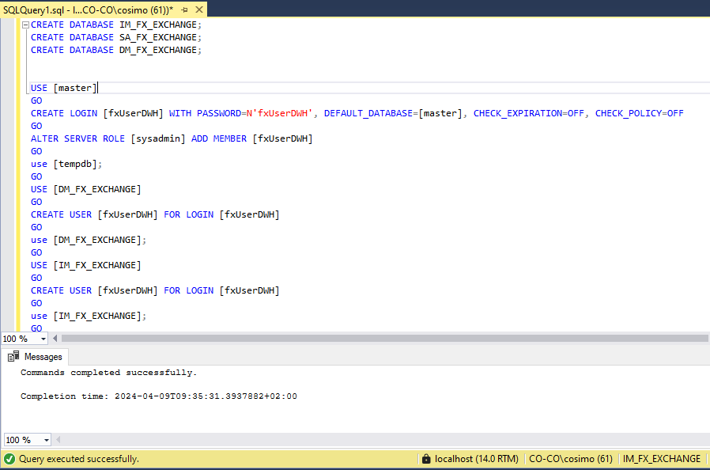
* Create SSISDB by creating a SSIS Catalog: right click on *Integration Services Catalog, Create Catalog…* In my case is obscure because I have already created it:

* Now it is possible to open the file *ForeingExchangeRate.sln* with Visual Studio and run the solution.
* To be honest, this is not a good choice, but we need to modify the connection string for the flat CSV data source. Open the solution as explained in the previous step, then go to *Connection Manager,* double click on Rates Sample CSV and change the path for the file.  
  Immagine che contiene testo, schermata, software, Icona del computer

  Descrizione generata automaticamente  
    
  It seems that it’s not possible to configure flat files in CSV by using relative paths. So, we need to insert the absolute path of the file